**Guide to using Lazar lab ImageJ macros**

**(v2, August 2020)**

1. **MACRO INSTALLATION AND EXECUTION**

Place the macro file and the files 2PPM_B.tif and 2PPM_C.tif into the macro folder of ImageJ or Fiji (do not place them in any subfolders inside the main macro folder). Open ImageJ, and go to Plugins → Macros → Install… and select the file with macros you would like to use. If you now click on Plugins → Macros you should see the following macros:

* **Process a polarization image (mixed image) [g]**
* **Process a polarization image (composite image) [z]**
* **Process a polarization image (multiple polarizations) [m]**
* **Combine 1P, 2P data [c]**
* **Determine alpha0, sigma from rmax, log2(rmax) [d]**
* **Fit by two Gaussian distributions [t]**
* **Predict LD [p]**

The collection of macros also contains several accessory macros, such as a macro for alignment of images within a stack, correction of bleaching during a time series, or showing the color coding of linear dichroism or azimuths.

The individual macros can be executed either by clicking on the name of the macro in the menu, or by pressing the key indicated within the square brackets.

1. **BRIEF DESCRIPTION OF THE INDIVIDUAL MACROS**

**Process a polarization image (mixed image) [g]**

This macro processes raw polarization (1PPM, 2PPM) microscopy images (containing some pixels acquired with horizontal polarization, some pixels acquired with vertical polarization of the excitation light), and produces background-subtracted images that show linear dichroism and allow its quantitation. Optionally, the macro also carries out quantitative analysis of LD (by guiding the user through segmentation, approximation of the membrane shape by a curve, and fitting the data from the segmented pixels by a function yielding parameters quantitating the observed LD and describing fluorophore orientation)

**Input:** a raw 1PPM or 2PPM image  
**Output:** an image showing linear dichroism as a red/green (or some other color combination) pattern.  
**Optional output:**   
- a graph of linear dichroism (log2(Fh/Fv)) as a function of cell membrane orientation (angle ), showing the values of rmax and log2(rmax)  
- a 32-bit image (_BIN.tif) with pixels of interest having the value of 1, background pixels having the value of NaN, containing an orange overlay showing the spline used for approximating the membrane shape  
- 16-bit images (_HOR.tif and _VER.tif) containing Fh and Fv  
- a text file (with a name ending with _1P_FIT.txt or _2P_FIT.txt) containing the values of rmax and log2(rmax) obtained by fitting {, log2(Fh/Fv)} data and values of fitting parameters.  
- a text file (_1P_ALL.txt or _2P_ALL.txt) containing, for each point on the spline approximating the cell surface, its x, y coordinates, direction (value of ), sums of Fh, Fv calculated for pixels closer to this point  
 than to any other point on the spline, the r value (Fh/Fv), and the numbers of such pixels  
- a 32-bit image (_THT.tif) showing, for each pixel of interest, the orientation of the cell membrane (angle ). The values of other pixels are set to NaN.  
- a 32-bit hyperstack (_1P_GFIT.tif or _2P_GFIT.tif) containing 4 channels. Channel 1 contains values of r2 (coefficient of determination) for various values of α0 and . Channel 2 contains values of RMSD for various combinations of α0 and . Channel 3 contains values of Chi-squared for various combinations of α0 and . Channel 4 shows the combinations of α0 and  that match the provided data. By default, channel 1 (r2) is colored by a black/cyan/white color scheme, in which dark shades indicate a poor fit and bright shades a good fit. The channel 2 and 3 images are colored by a red-white-blue color scheme, in which red color corresponds to large values (poor fit), white corresponds to smaller values of (a better fit), and blue indicates good agreement with the data from the processed image. The x, y coordinates of pixels within the images correspond to values of α0 and  (in degrees), with the origin (α0 =0,  = 0) in the bottom left corner of the image.  
- record in the ‘Log’ window of ImageJ

**Process a polarization image (composite image) [z]**

This macro is identical to the macro for processing mixed polarization images (macro ‘g’), except it takes as its input a 2-slice composite image, with each slice showing fluorescence observed with one linear polarization of the excitation light. The two polarizations used are expected to be perpendicular.

**Process a polarization image (multiple polarizations) [m]**This macro is similar to macros ‘g’ and ‘z’, but processes stacks of images in which each image is acquired using a distinct polarization of excitation light. The macro produces images showing the extent of linear dichroism, as well as the polarization directions eliciting the highest amount of fluorescence. Optionally, this macro (similarly to macros ‘g’ and ‘z’) also carries out quantitative analysis of LD, by guiding the user through segmentation, approximation of the membrane shape by a curve, and fitting the data from the segmented pixels by a function yielding parameters quantitating the observed LD and describing fluorophore orientation.

**Input:** a stack of images acquired with distinct, regularly spaced linear polarizations of excitation light  
**Output:** an image showing linear dichroism as a color hue, while showing fluorescence intensity as brightness. Optionally, the image also shows (as an overlay) the directions of polarizations eliciting the highest level of fluorescence

**Optional output (similar to, but somewhat distinct from macros ‘g’, ‘z’):**   
- a graph of linear dichroism (log2(Fh/Fv)) as a function of cell membrane orientation (angle ), showing the values of rmax and log2(rmax) (_FIT.png, _FIT.tif)  
- a 32-bit image (_BIN.tif) with pixels of interest having the value of 1, background pixels having the value of NaN, containing a rainbow-colored overlay showing the spline used for approximating the membrane shape  
- a background subtracted multi-polarization stack (_B-subbed.tif)  
- a text file (with a name ending with _1P_FIT.txt or _2P_FIT.txt) containing the values of rmax and log2(rmax) obtained by fitting {, log2(Fh/Fv)} data and values of fitting parameters.  
- a text file (_1P_ALL.txt or _2P_ALL.txt) containing, for each point on the spline approximating the cell surface, its x, y coordinates, direction (value of ), sums of Fh, Fv calculated for pixels closer to this point  
 than to any other point on the spline, the r value (Fh/Fv), and the numbers of such pixels  
- a 32-bit image (_THT.tif) showing, for each pixel of interest, the orientation of the cell membrane (angle ). The values of other pixels are set to NaN.  
- a 32-bit hyperstack (_1P_GFIT.tif or _2P_GFIT.tif) containing 4 channels. Channel 1 contains values of r2 (coefficient of determination) for various values of α0 and . Channel 2 contains values of RMSD for various combinations of α0 and . Channel 3 contains values of Chi-squared for various combinations of α0 and . Channel 4 shows the combinations of α0 and  that match the provided data. By default, channel 1 (r2) is colored by a black/cyan/white color scheme, in which dark shades indicate a poor fit and bright shades a good fit. The channel 2 and 3 images are colored by a red-white-blue color scheme, in which red color corresponds to large values (poor fit), white corresponds to smaller values of (a better fit), and blue indicates good agreement with the data from the processed image. The x, y coordinates of pixels within the images correspond to values of α0 and  (in degrees), with the origin (α0 =0,  = 0) in the bottom left corner of the image.  
- record in the ‘Log’ window of ImageJ

In contrast to macros ‘g’ and ‘z’, macro [m] can optionally also output:  
- a plot of LD along the length of the spline used for shape approximation (_L2R_trace.png, _L2R_trace.tif). The plot also shows the goodness of fit (expressed as r2) of the LD data along the spline. Position along the spline is indicated by the color of the rainbow-colored x-axis. Colors of the x-axis correspond to the colors of the spline shown in the _BIN.tif image file.  
- a plot showing, for each point on the spline used for shape approximation, the direction of the spline, as well as the direction of polarization that excites the highest amount of fluorescence at that position along the spline. Position along the spline is indicated by the color of the rainbow-colored x-axis. Colors of the x-axis correspond to the colors of the spline shown in the _BIN.tif image file.

**Combine 1P, 2P data [c]**This macro combines results of analyses (by macro ‘g’, ‘z’ or ‘m’) of 1P and/or 2P fluorescence images and performs data fitting/statistical analysis on the combined data set.

**Input:** a folder/folders of output files generated by the ‘g’, ‘z’, or ‘m’ macro. Strictly speaking, within the folder(s), only files whose names end with _1P_FIT.txt, _1P_ALL.txt, _2P_FIT.txt and _2P_ALL.txt are required.  
**Output:**  
- a graph of linear dichroism (log2(Fh/Fv)) as a function of cell membrane orientation (angle ), combining data from 1PPM and/or 2PPM files in the selected directories, displayed, and saved as a .png and a .tif file. The .tif file, when re-opened in ImageJ, allows modifying graph settings.  
- values of α0, , obtained by fitting only the 2PPM data, and both 1PPM and 2PPM data  
- a 32-bit hyperstack (‘goodness_of_fit_...*date*_*time*.tif’) containing 4 channels (r2; RMSD; Chi-squared; α0, ) and 3 t-slices (1PPM data; 2PPM data; a combination of 1PPM and 2PPM data) describing the agreement between experimental data and each possible combination α0, . The hyperstack is analogous to that produced by the [g] macro. Unlike the hyperstack created by the [g] macro, the hyperstack created by the [c] macro contains colorful overlays, indicating combinations (and confidence intervals) of α0,  values that are consistent with the data being analyzed.

- a log file (combined_1P_2P_data_fitting_log.txt), containing information on success/failure of parsing information from the individual 1PPM/2PPM files, as well as the information parsed (values of rmax, log2(rmax), phase, goodness of fit, etc.).

**Determine alpha0, sigma from rmax, log2(rmax) [d]**This macro generates a graph (heat map) showing which combinations of values of α0 and  are compatible with the extent of 1P and/or 2P LD entered by the user.

**Input:** value(s) of LD (either in the form of of rmax or log2(rmax)), obtained from 1P and/or 2P measurements, including confidence intervals (either as values, or percentages of the mean value).  
  
**Output:**  
- an RGB image: a heat map showing which combinations of α0,  are compatible with the entered values of 1P LD (shown in blue color), 2P LD (shown in red color), and both (shown in magenta).

**Fit by two Gaussian distributions [t]**This macro looks for combinations of two Gaussian distributions of molecular orientations that would best fit the 1PPM/2PPM observations.

**Input:** fitting parameters B1P, B2P, C2P, obtained from macros ‘g’, ‘z’, ‘m’ or ‘c’  
**Output:**  
- a list of α0,  values for pairs of Gaussian distributions, the percentages of their representations, along with the corresponding RMSD values and distribution entropies.

**Predict LD [p]**This macro calculates LD (as a function of membrane orientation) based on 0,  parameters entered by the user, and displays the results as a plot.

**Input:** values of α0,  entered by the user.  
  
**Output:**  
- a plot of 1P and 2P log2(r), (shown in blue and red color, respectively), as a function of membrane orientation. Descriptive parameters of the plot (rmax, log2(rmax)), *B*1P, *B*2P, *C*2P) are shown.

**Accessory: Show current two-polarization color scheme [I]**This macro generates an image showing the range of colors that encode the selected range of dichroic ratios, within the color scheme used last by macro ‘g’ or ‘z’.

**Input:** none (uses information on the last used color scheme that is saved in a config file).  
  
**Output:**  
- an image showing the color range used by the [g] macro

**Accessory: Show current multi-polarization color scheme [i]**This macro generates an image showing the range of colors that encode the selected range of dichroic ratios, within the color scheme used last by macro ‘m’.

**Input:** none (uses information on the last used color scheme that is saved in a config file).  
  
**Output:**  
- an image showing the color range used by the [m] macro

**Accessory: Show azimuth color wheel [o]**This macro generates an image showing the colors used to indicate directions of azimuths.

**Input:** none   
  
**Output:**  
- an image showing the color coding of azimuth directions

**Accessory: Align stack [a]**This macro aligns slices within a stack. It relies on the StackReg plugin, which must be installed in order for the macro to work.

**Input:** an image stack   
  
**Output:**  
- an image stack with the individual slices aligned

**Accessory: Compensate for bleaching [b]**This macro corrects for bleaching during acquisition of image stacks. The macro identifies an area of background, subtracts from each slice the intensity measured from its background area, calculates the extent of bleaching from the background-subtracted slices, multiplies each slice (except the first slice) by a factor calculated to compensate for bleaching, and adds back background intensity.

**Input:** an image stack   
  
**Output:**  
- an image stack with intensities of the individual slices corrected for bleaching

1. **USING THE INDIVIDUAL MACROS**

**Process a polarization image (mixed image) [g]**

The ‘g’ macro allows the user to visualize linear dichroism, as well as to perform quantitative analysis of linear dichroism. During its execution, the macro requests values of various processing parameters, suggesting suitable values based on analysis of the image being processed. Some of the processing parameters have to do with the hardware of the imaging setup, others with user preferences. The macro then uses the provided processing parameters to generate an image that shows both overall fluorescence intensity (encoded as image brightness) and linear dichroism (= differences between Fh and Fv)(encoded as hue). After displaying the initial processed image, the macro keeps offering the user to modify the processing parameters and displaying the corresponding image, until the user approves the parameter values without any modification.

 

|  |  |
| --- | --- |
| A raw 2PPM image | An image showing fluorescence intensity and linear dichroism (as brightness and hue, respectively), made by the ‘g’ macro using automatically determined processing parameter values |

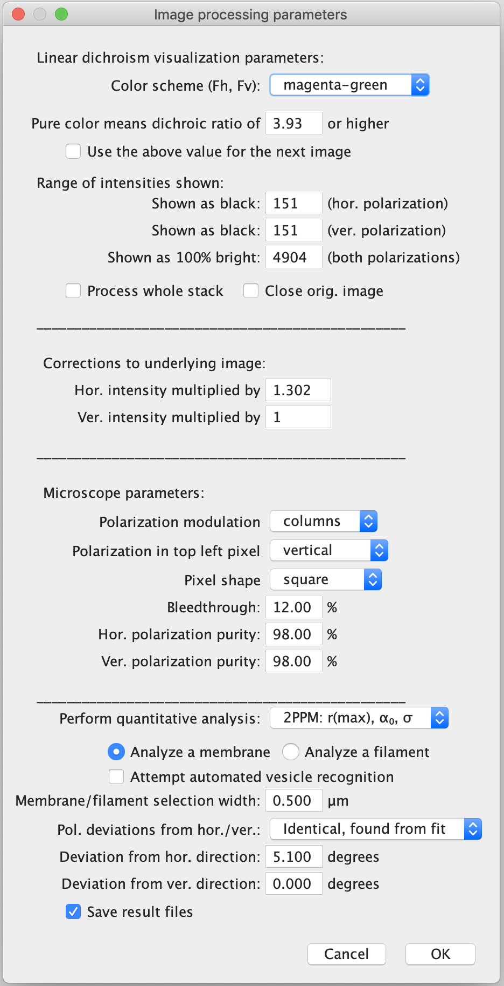**Color scheme** – select the color scheme used for displaying linear dichroism **Pure color means…** – defines what range of Fh/Fv values will be covered by the used color range; color contrast   
 **Shown as black** – values used for background subtraction in Fh, Fv images. The default values are calculated by the macro by finding the darkest rectangle of 10% width x 10% height of the image  **Shown as 100% bright** – defines what fluorescence intensity will be displayed as fully bright (within the chosen color scheme)  
 **Process whole stack** – if marked, the macro will process the whole stack of images. Otherwise, only the current slice of a stack will be analyzed  
 **Close original image** – if marked, the macro will close the raw 1PPM/2PPM image upon completion.  
 **Hor./ver. intensity multiplied by** – factors by which the Fh, Fv images need to be multiplied in order to obtain Fh, Fv images of equal overall intensities   
 **Pol. modulation** – select ‘columns’ or ‘rows’, depending on what your microscope uses  
 **First pixel polarization** – select what the excitation light polarization is in the top left pixel of the image  
 **Pixel shape** – should be set to ‘square’, unless the scanning resolution is different in the horizontal and vertical directions.  **Bleedthrough** – how much fluorescence of one pixel gets reported in the next pixel  
 **Hor./ver. polarization purity** – purity of polarization for the two directions  
 **Perform quantitative analysis** – select ‘1PPM’, ‘2PPM’ or ‘none’, depending on the type of data processing desired.

**Analyze a membrane/Analyze a filament** – select what type of sample you are processing. This will determine whether the model used to determine α0,  will use the direction perpendicular to the selected feature (membrane normal) or the direction of the feature itself (filament axis) as an axis of symmetry.  
  
**Attempt automated vesicle recognition** – when selected, the macro will try to find a round vesicle in the image and perform automated image segmentation  
  
**Membrane/filament selection width** – enter the width of the membrane/filament outline that should be used in quantitative analysis. Typically, values around 0.5 µm are reasonable.  
 **Deviations from hor./ver. direction** – select ‘found from fit’ in order for the macro to analyze the LD data for deviations of the used polarizations from exactly horizontal/vertical directions. This option should be used when high quality data, suitable for such analysis, is available. Otherwise, ‘set by user’ should be selected, and the values of such deviations should be entered into the fields below. The values of deviations of polarization directions from horizontal/vertical can be set to be ‘identical’ or ‘distinct’. Only high quality data allows determinations by the macro of distinct values of deviations of horizontal and vertical polarization directions. Setting the values of these deviations manually by the user simplifies the data fitting algorithm, and reduces the chances of fitting failure.  
 **Save result files** – if checked, the macro will ask the user to select a directory for saving the processing and result files.

After manually adjusting the processing parameters, press ‘OK’. If no parameter values are modified prior to pressing ‘OK’, the image will be processed using the entered parameters and the dialog will not appear again.

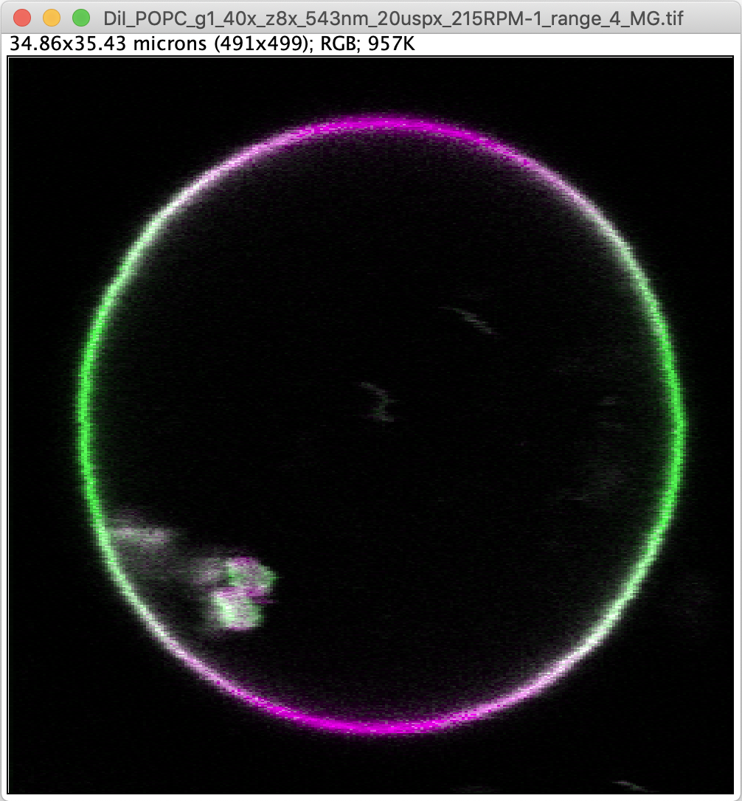

An image made by the ‘g’ macro, showing linear dichroism as shades of magenta/green.

|  |  |
| --- | --- |
|  |  |

Left: a message window offering the user to make changes to the segmentation/membrane shape approximation performed by the macro. Right: an image of a vesicle with its shape approximated by a spline, and a part of its outline removed by a paintbrush tool

Based on the user selection in the main dialog window, the macro will attempt to find in the image either a round vesicle or an irregularly shaped cell. For round vesicle identification, it is recommended that the Hough circle transform plugin (of the UCB Vision Sciences plugin package) be installed. The result of the automated shape approximation is displayed as a spline selection overlaid over the image. The width of the spline indicates the width of the segmented area. The shape of the spline can be adjusted by dragging the individual anchor points. A new selection can be made by the polygon or segmented line tool, followed by a spline fit (menu Edit → Selection → Fit Spline or by pressing the ‘f’ key). Alternatively, a new automated shape approximation can be performed with a modified initial guess, by selecting 3 points belonging to the outline of a round vesicle (to search for round vesicles) or by selecting a single point approximately in the center of a cell (to search for an irregular membrane shape). The results of the automated shape finding procedure can at this point also be altered by using the paintbrush tool (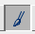) to erase unwanted parts of the image that may affect the spline fitting results. All pixels modified by the paintbrush tool will be excluded from further analysis. Previously made selection can be restored by pressing ‘Ctrl + Shift + e’.

Upon pressing ‘OK’ (without making changes to the image or to the spline), the macro calculates the direction of the spline (which is defined by ~500 points). The algorithm associates each segmented pixel of the image being analyzed with a nearest point on the spline. For each point of the spline it calculates the sum of fluorescence intensities of the pixels associated with that point of the spline. This is done separately for fluorescence excited by light polarized horizontally (*F*h) and by light polarized vertically (*F*v). For each point of the spline the macro then calculates the value of *r* (*r* = *F*h/*F*v) and log2(*r*), and creates a plot of log2(*r*) values as a function of membrane orientation (angle θ). The data is fitted by a function, whose form depends on user input in the main dialog. For single-photon excitation (1PPM), the fitting is performed using the following equation:

$$\log_{2}(r)=A+\log_{2}\left(\frac{1+B_{1P}cos\left(2θ-2φ_{1}\right)}{1-B_{1P}cos\left(2θ-2φ_{2}\right)}\right)$$

, where *A*, *B1P*, and **, **  are fitting parameters, and *r* and θ are variables. The value of the offset parameter *A*, compensating for different intensities of illumination with the two used polarizations, is set to 0 if small amount of data is available. The phase parameters (**, **), compensating for deviations from exactly horizontal and vertical directions of the used polarizations can be set by the user in the main dialog to be identical, to have specific values, or to be determined by the fitting algorithm. Leaving the values of ** and ** to be distinct and determined by the fitting algorithm will make the fitting procedure more likely to fail, and is advisable only when high quality data is being processed.

The results of the data fitting are displayed in the form of a plot, as well as composite image, whose individual slices show agreement of the LD data with various combinations α0,  values, as evaluated by various statistical measures (*r*2, RMSD, Chi2). The fitting yields values of the parameters *B*1P, **, and **, but also the value of *r*max (and log2(*r*max)), which is a value characteristic of a particular molecular system, defined as *r*max = *r*θ=0, that *r*max = *F*h/*F*v in a section of a membrane oriented horizontally (θ = 0).

|  |  |
| --- | --- |
|  |  |

Results of quantitative analysis of a 1PPM image of a vesicle. Left: a plot of LD (log2(*F*h/*F*v)) as a function of membrane orientation (angle θ), showing the data, the fit, and the fitting parameters. The plot style can be adjusted in the ‘More’ menu. Right: individual slices of a ‘goodness-of-fit’ image generated by the ‘g’ macro. The ‘r2’ slice shows the values of a coefficient of determination (*r*2). Black color corresponds to *r*2 = 0, white color corresponds to *r*2 = 1. Therefore, bright regions correspond to combinations of values of α0,  that are consistent with the LD data. In the RMSD slice, dark blue color corresponds to the lowest RMSD value found (RMSDmin), while red color corresponds to values of RMSD larger than 5× RMSDmin. In the Chi2 slice, combinations of α0,  that can be excluded with confidence higher than 95% are colored red. Finally, the α0,  slice shows combinations of α0,  whose RMSD is larger than RMSDmin by less than 1%. The text indicating what is being shown can be hidden by Image → Overlay → Hide Overlay.

For two-photon excitation (2PPM), the fitting is performed using the following equation:

$$\log_{2}(r)=A+\log_{2}\left(\frac{1+B_{2P}cos\left(2θ-2φ_{1}\right)+C_{2P}cos\left(4θ-4φ_{1}\right)}{1-B_{2P}cos\left(2θ-2φ_{2}\right)+C_{2P}cos\left(4θ-4φ_{2}\right)}\right)$$

where *A*, *B2P*, *C2P* and **, **  are fitting parameters, and *r* and θ are variables. The meaning of the parameters is similar to those used in the 1PPM fitting procedure described above.

|  |  |
| --- | --- |
|  |  |

Results of quantitative analysis of a 2PPM image of a vesicle. Left: a plot of LD (log2(*F*h/*F*v)) as a function of membrane orientation (angle θ), showing the data, the fit, and the fitting parameters. The plot style can be adjusted in the ‘More’ menu. Two types of fitting are performed and shown: in dark red, a fit with the parameters *B2P*, *C2P* unrestricted; in bright red, a fit with the *B2P*, *C2P* values restricted to those consistent with a Gaussian distribution of fluorophore tilt angles. Right: individual slices of a ‘goodness-of-fit’ image generated by the ‘g’ macro. The meaning is similar to those made for 1PPM data, with the exception of a single combinations of α0,  values (marked by a red overlay) matching the data the best.

Apart from displaying (and saving) the fitting data, the macro can also (when chosen by the user in the main dialog) save the images of fluorescence acquired with excitation light polarized horizontally (as a _HOR.tif file) and vertically (_VER.tif), the segmentation and outline direction information (_BIN.tif, _THT.tif files), and the LD data (_FIT.txt, _ALL.txt files). The progress and results of the fitting procedure are also summarized in ImageJ’s Log window.

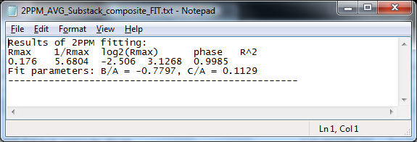  
Example of a _FIT.txt file

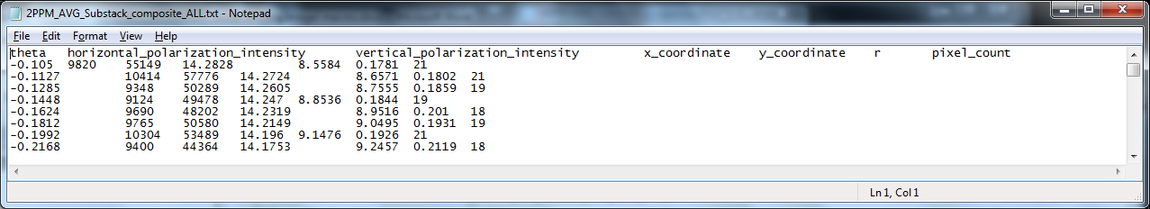Example of an _ALL.txt file

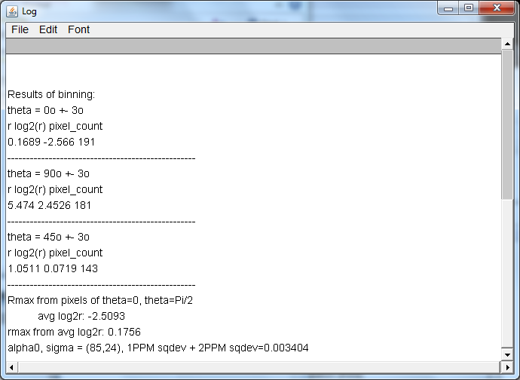

Example of ImageJ’s Log window, showing the output of the ‘g’ macro.

**Process a polarization image (composite image) [z]**

Macro [z] functions identically to macro [g], but instead of processing images containing pixels acquired with two perpendicular polarizations it processes stacks of two images, each image acquired with a distinct (horizontal, vertical) polarization.

**Process a polarization image (multiple polarizations) [m]**

Macro [m] functions similarly to macro [g] and [z], but instead of processing images containing pixels acquired with two perpendicular polarizations it processes stacks of at least 4 images acquired with distinct excitation light polarizations. Macro [m] allows the user to visualize linear dichroism, molecular azimuths (= polarization directions yielding, for a given area, the highest amount of fluorescence), as well as to perform quantitative analysis of linear dichroism. Prior to processing an image stack with the [m] macro, we recommend aligning the individual slices within the stack (by using the accessory stack alignment macro, or by some other tool), as well as correcting for bleaching (by using the accessory bleaching correction macro).

|  |  |
| --- | --- |
| A starting image stack, containing images acquired using distinct polarizations of excitation light | A final image, showing the extent of linear dichroism (by the shade of magenta coloring) and the directions of polarizations that elicit the maximum fluorescence intensity (molecular azimuths) by white lines |

During its execution, the [m] macro requests, through its main dialogue, values of various processing parameters. The dialogue shows values predetermined from previous user input, as well as from analysis of the image being processed. Some of the processing parameters have to do with the hardware of the imaging setup, others with user preferences. The macro then uses the provided processing parameters to generate an image that shows both the overall fluorescence intensity (encoded as image brightness) and linear dichroism (= differences between Fh and Fv)(encoded as color saturation). After displaying the initial processed image, the macro keeps offering the user to modify the processing parameters and displaying the corresponding image, until the user approves the parameter values without any modification.

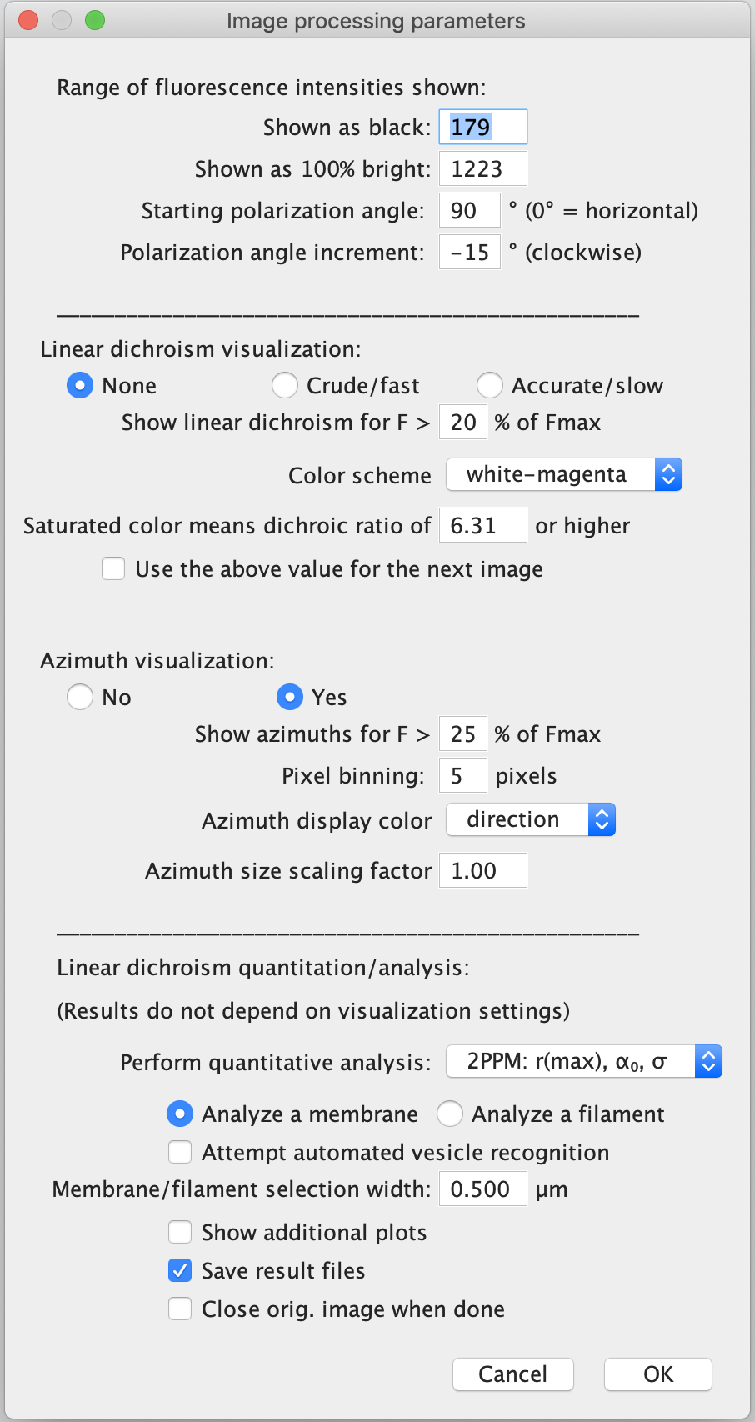

**Shown as black** – value used for background subtraction. The default value is calculated by the macro by finding the darkest rectangle of 10% width x 10% height of the image  **Shown as 100% bright** – defines what fluorescence intensity will be displayed as fully bright (within the chosen color scheme); brightness adjustment

**Starting polarization angle** – polarization used in the first image of the stack (0° = horizontal direction)  
 **Polarization angle increment** – self-explanatory  
  
**Linear dichroism visualization** – allows the user to select whether and how linear dichroism is calculated/displayed. The ‘Crude/fast’ option uses pixel binning. The ‘Accurate/slow’ option makes linear dichroism to be calculated separately for each pixel of intensity above the selected threshold

**Show linear dichroism for…** – limits calculating and displaying linear dichroism to parts of the image brighter than the set cutoff  
  
**Color scheme** – select the color scheme used for displaying linear dichroism  
  
**Azimuth visualization** – turns calculating/displaying azimuths on or off  
  
**Show azimuths for…** – limits calculating and displaying molecular azimuths to parts of the image brighter than the set cutoff  
  
**Pixel binning** – sets the size (in pixels) of square areas used for calculating and displaying the molecular azimuths  
  
**Azimuth display color** – sets the color of the displayed azimuths. Selecting the option ‘direction’ colors the azimuths according to their direction.

**Azimuth size scaling factor** – allows the user to scale the length of the lines indicating azimuths

**Perform quantitative analysis** – select ‘1PPM’, ‘2PPM’ or ‘none’, depending on the type of data processing desired.

**Analyze a membrane/Analyze a filament** – select what type of sample you are processing. This will determine whether the model used to determine α0,  will use the direction perpendicular to the selected feature (membrane normal) or the direction of the feature itself (filament axis) as an axis of symmetry.  
 **Attempt automated vesicle recognition** – when selected, the macro will try to find a round vesicle in the image and perform automated image segmentation

**Membrane/filament selection width** – enter the width of the membrane/filament outline that should be used in quantitative analysis. Typically, values around 0.5 µm are reasonable.

**Show additional plots** – when selected, the macro will display two additional plots: 1) a plot of linear dichroism (values of log2(*r*max)) along the selected outline, and 2) a plot of molecular azimuths and directions of the user-selected outline  
 **Save result files** – if checked, the macro will ask the user to select a directory for saving the processing and result files.  
  
**Close orig. image when done** – if marked, the macro will close the starting polarization microscopy image stack upon completion

After manually adjusting the processing parameters, press ‘OK’. If no parameter values are modified prior to pressing ‘OK’, the image will be processed using the entered parameters. Based on the user selections in the main dialog window, the macro will visualize linear dichroism and molecular azimuths. Both the extent of linear dichroism and azimuth directions are calculated by fitting the temporal profile of fluorescence intensity by sinusoidal function. The magnitude of linear dichroism is taken to be the amplitude of this sinusoidal function, while the azimuth corresponds to the phase of the sinusoidal. The extent of linear dichroism is indicated in the processed image not only by color, but also by the lengths of the displayed azimuths.

Choosing the azimuth display parameters can heavily affect the overall appearance of the resulting image. By choosing azimuth coloring by direction, in combination with setting ‘Azimuth pixel binning’ to 1 and ‘Azimuth size scaling factor’ to a small value (such as 0.01), this macro allows creating images of azimuth orientations, as shown below. The azimuths are shown as an overlay over the image of linear dichroism. This overlay can be hidden or otherwise manipulated in ImageJ (menu Image → Overlay → …)

|  |  |
| --- | --- |
| Azimuth display color = white Azimuth pixel binning = 10 Azimuth size scaling factor = 1 | Azimuth display color = orientation Azimuth pixel binning = 1 Azimuth size scaling factor = 0.01 |

The [m] macro allow quantitative analysis and interpretation of linear dichroism. To a large extent, the implementation of this functionality is identical to that of macros [g] and [z], and its description can be found there. In order to take advantage of applicability of gaussian statistics to logratios, and in order to maintain consistent data processing, the macro [m] analyzes data from multiple-polarization images by calculating (and plotting) the logratios of fluorescence intensities for pairs of perpendicular polarizations. This allows easy visualization of data quality and fit robustness. A disadvantage of this approach is that it cannot be applied to images acquired with polarizations that do not contain perpendicular pairs.

Apart from the linear dichroism capabilities analogous to those provided by the [g] and [z] macros, the [m] macro allows creating two additional plots: a plot of linear dichroism for different positions along the selected outline, and a plot of azimuth directions and orientations of the selected outline.



An image showing linear dichroism (as saturation of red color), azimuths (as cyan-colored lines), and the selected outline (rainbow-colored, in order for color to indicate the position on the outline)



A plot of outline orientation (red circles) and molecular azimuths (black dots; determined as the phase of a sinusoidal function fit of the fluorescence data), for various positions (indicated by the rainbow-colored x-axis) along the selected outline. The coloring of the x-axis corresponds to the coloring of the selected outline in the image of the cell above. Deviations of azimuths (black dots) from outline directions (red circles) indicate deviations of the selected outline from the true orientation of the observed feature (in this case, the cell membrane)  
  
  
  
  
Plot of linear dichroism (red line; values of log2(rmax)) and goodness of fit (black circles; r-squared) for different positions (indicated by the rainbow-colored x-axis) along the selected outline. The coloring of the x-axis corresponds to the coloring of the selected outline in the image of the cell above. Parts of the outline were not analyzed, as they were deselected by the user during the segmentation procedure.

**Determine alpha0, sigma from rmax, log2(rmax) [d]**  
This macro generates a graph (heat map) showing which combinations of values of α0,  are consistent with the extent (*r*max, log2(*r*max)) of 1P and/or 2P LD entered by the user. It is important to note that while for 1PPM the extent of LD (*r*max, log2(*r*max)) fully describes the LD along the membrane, this is not the case for 2PPM. In 2PPM observations, the extent of LD for different orientations of the membrane (angle θ) cannot be determined from *r*max (or log2(*r*max)) and θ alone. Thus, macro ‘d’, by taking into account only the 2P *r*max value instead of the full *r*(θ) profile, finds more α0,  combinations consistent with the 2P data than would be optimal. The full accounting for 2P data can be performed by macro ‘c’, which is, however, considerably more complex.

Upon execution, macro ‘d’ displays a dialog, expecting the user to enter values of 1P and/or 2P LD, and the respective confidence intervals. Depending on the user selection, the values entered can be values of *r*max or log2(*r*max), and the confidence intervals can be entered either as percentages of the mean value, or as ranges of values.

|  |  |
| --- | --- |
|  |  |

Examples of the macro ‘d’ main dialog, with sample values entered.

After pressing ‘OK’, the macro creates a heat map showing combinations of 0,  values consistent with the entered values:

|  |  |
| --- | --- |
|  | An image made by the ‘d’ macro, showing combinations of 0,  values consistent with the entered 1P data (in blue) and 2P data (in red) |

**Combine 1P, 2P data [c]**

The ‘c’ macro combines results of multiple 1P and/or 2P polarization microscopy observations, and uses them to determine the values of α0, . Unlike the ‘Determine alpha0, sigma from rmax, log2(rmax) [d]’ macro, the ‘c’ macro uses the full LD data, not just the *r*max or log2(*r*max) values. Therefore, the ‘c’ macro generally represents a more proper way to analyze the combined 1P/2P data, although it is somewhat more demanding to use, and the results can be more complex and harder to intuitively understand.

Upon execution, the ‘c’ macro asks the user to select a file within a directory containing the analyzed 1P data (generated by the ‘g’, ‘z’ or ‘m’ macros). Next, the ‘c’ macro asks the user to select a file within a directory that contains the desired 2P data. The ‘c’ macro searches the respective directories for files whose names end with _1P_FIT.txt, _1P_ALL.txt, _2P_FIT.txt, and _2P_ALL.txt. If only files generated by one of the two fluorescence excitation modalities can be found in the specified directories, then results obtained by only one of the approaches are combined. After finding all the 1P and/or 2P result files, the ‘c’ macro extracts and combines all the available 1P/2P data, performs fitting, and generates a plot of log2(*r*max) values as a function of membrane orientation (angle θ), and a goodness-of-fit image that summarize the results.

The plot shows the 1P data (if available) in the left half of the plot, and the 2P data (if available) in the right half of the plot. The macro performs fitting of the 1P data, of the 2P data, and of the combined 1P/2P data set. The best fit made from only the 1P data is shown as a blue line. The best fit made by using only the 2P data is shown as a red line, which spans across 1P data (as 2P data allow predicting 1P LD values, but not vice versa). Finally, the best fit made by using both the 1P and 2P data is shown as a magenta line. The values of α0,  and RMSD are shown for the 2P-only and 1P/2P combined fits.

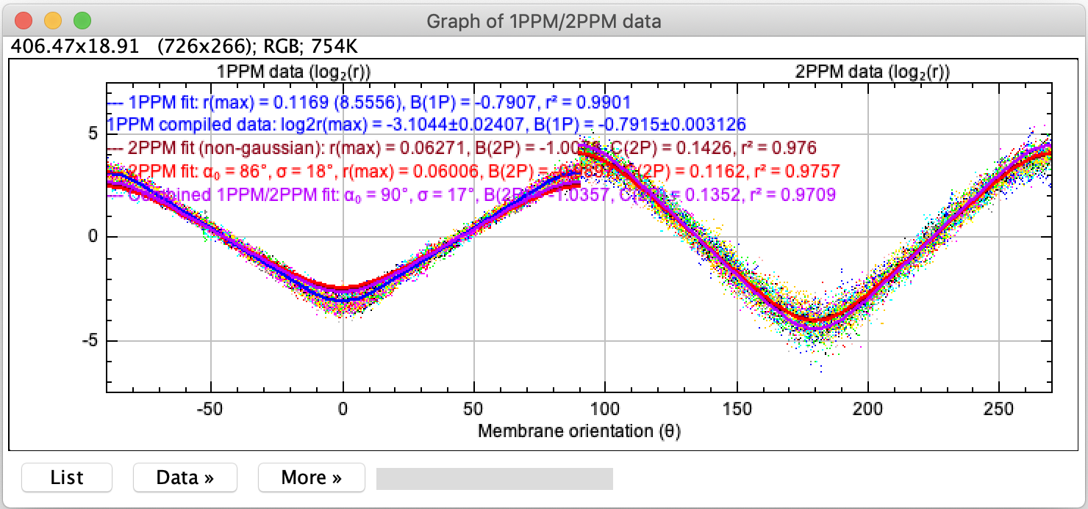 Data from 1PPM experiments Data from 2PPM experiments

A plot generated by the ‘c’ macro, showing the 1P data in the left half and 2P data in the right half of the plot. Curves (blue, red and magenta) were generated by fitting, respectively, of only the 1P data, only the 2P data, and both the 1P and 2P data. The settings of the plot can be modified in the ‘More’ menu.

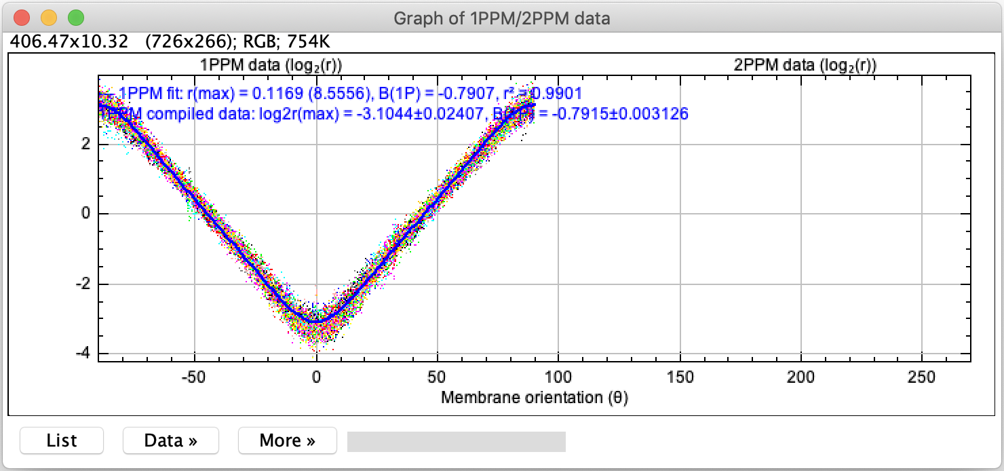  
A plot generated by the ‘c’ macro, from 1P data only. The blue line and the accompanying legend represent a fit of the combined 1P data. 1P data is generally consistent with multiple Gaussian distributions of molecular orientations, and thus does not allow prediction of 2P data.

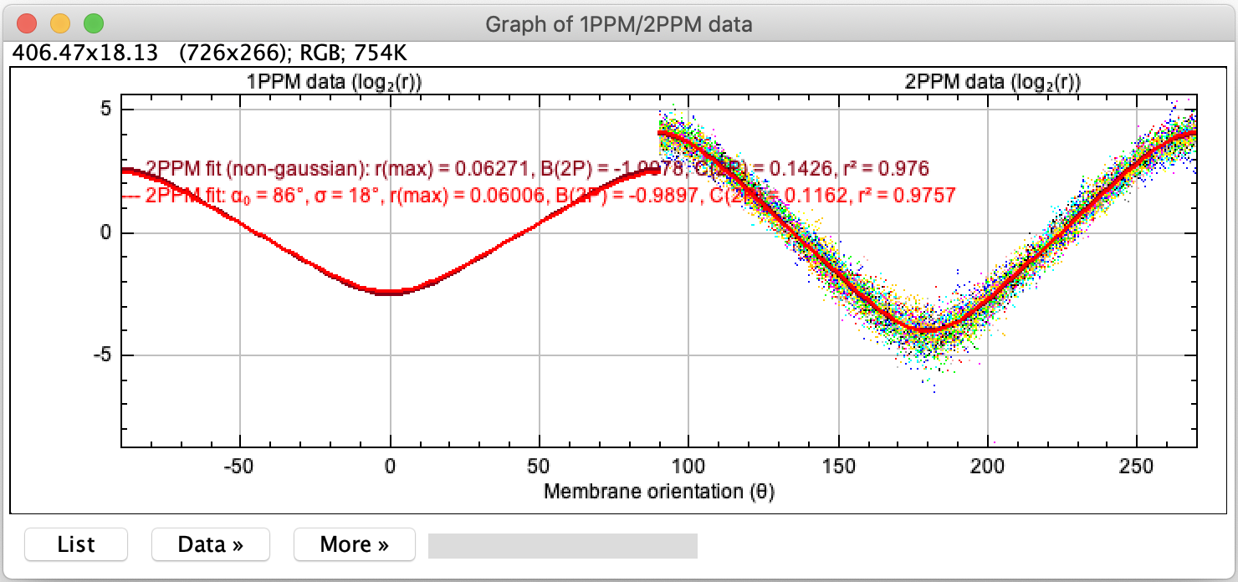

A plot generated by the ‘c’ macro, from 2P data only. The dark red line and the accompanying legend represent a fit made without restricting the values of the fitting parameters *B*2P, *C*2P to any particular type of distribution of molecular orientations. The bright red line and the accompanying legend represent a fit made by restricting the values of the fitting parameters *B*2P, *C*2P to Gaussian distributions of molecular orientations. Based on this fit, a prediction can be made of 1PPM data, which is also shown in the plot.

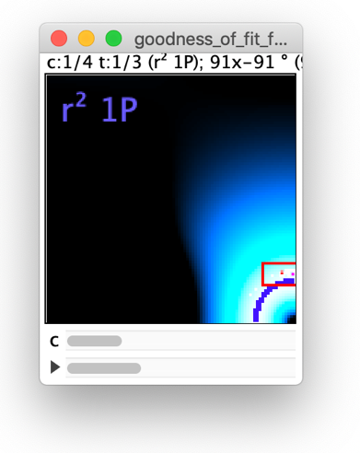

A 32-bit hyperstack image showing the r2, RMSD, Chi-squared, and α0,  values as the individual hyperstack channels. Information derived from 1P only, 2P only, and combined 1P and 2P data is shown in respective hyperstack t-slices. The meaning of the individual images is the same as that described for macros ‘g’. The descriptive text and other overlays can be hidden by Image → Overlay → Hide Overlay.

Colorful overlays (described in more detail below) indicate α0,  values matching particular data type  
the LD data

The channel slider (c) allows switching between RMSD, Chi-squared and α0,  images

The t-slice slider allows switching between 1P, 2P and combined 1P+2P data

The goodness-of-fit image contains colorful overlays, with the following meanings:  
- A blue overlay (, RGB 50, 50, 255) indicates α0,  values that are consistent with the combined 1P data being analyzed.   
- A red overlay (, RGB 255, 0, 0) shows the mean (a single pixel) and 95% confidence interval (a rectangle) of α0,  values obtained from individual 2P traces.   
- A single light red (, RGB 255, 150, 150) pixel indicates the α0,  pair that matches the pooled 2P data the best.   
- A magenta pixel (, RGB 255, 0, 255) indicates the α0,  combination that matches the combined 1P, 2P data the best.

**Fit by two Gaussian distributions [t]**

The ‘t’ macro uses the values of parameters *B*2P and *C*2P (and optionally *B*1P) found by fitting 1P/2P data by macros ‘g’, ‘z’, ‘m’ or ‘c’, and tries to find a combination of two Gaussian distributions of molecular orientations that would best match the provided values.

|  |  |
| --- | --- |
|  | The main dialog of macro ‘t’, asking the user to enter the values of parameters *B*2P and *C*2P (and optionally *B*1P), as well as the ranges and sampling intervals of parameters of the two Gaussian distributions of molecular orientations the macro should use. |

Apart from asking for values of parameters *B*2P and *C*2P (and optionally *B*1P), the macro also asks the user to provide the sampling intervals for angles α0, and , as well as for the fractional representations of the individual Gaussian distributions (expressed in terms of %). Finding the best-fitting combination of Gaussian distributions can be a computationally demanding task. For example, using sampling intervals of 1 degree (for α0, and ) and 1% (for the composition), requires the macro generates 8281 Gaussian distributions (all combinations of 91 values α0, 91 values ), combines each of them with each of 8281 other Gaussian distributions, at 50 different ratios (99% molecules belonging to one Gaussian distribution + 1% molecules belonging to the other Gaussian distribution; 98% + 2%; 97% + 3% and so on). This way, close to 3.5 x 109 combinations must be generated and tested for how well they match the provided parameters *B*2P and *C*2P (and optionally *B*1P). In order to speed up the calculations, many of them are being run in parallel, which requires relatively large amounts of memory. At least 2 GB, but preferably 4 GB of RAM need to be available to ImageJ in order for this calculation to run. Reducing parameter ranges and increasing sampling interval sizes dramatically reduces the computational time, as well as the demands for computer memory. For sampling intervals of 1 degree (for α0, and ) and 1% (composition), the execution time of the [t] macro is around 5 minutes. Execution of the ‘t’ macro can be aborted at any point by pressing the ‘Escape’ key.

The [t] macro results are provided as a table in the Log window, listing for each combination of distributions (100% + 0%, 99% + 1%, 98% + 2%, etc.) the distributions (characterized by the parameters  
{α01,  and α02, }) that yield values of *B*2P and *C*2P (and optionally *B*1P) closest to the ones entered by the user, judged by RMSD. However, as the macro works with internal precision of 4 decimal places, very small values of RMSD (< ~0.001) may not be accurate. Apart from calculating RMSD, the macro also calculates entropy of the identified combinations of distributions. Low entropy values indicate distributions that are not very likely.

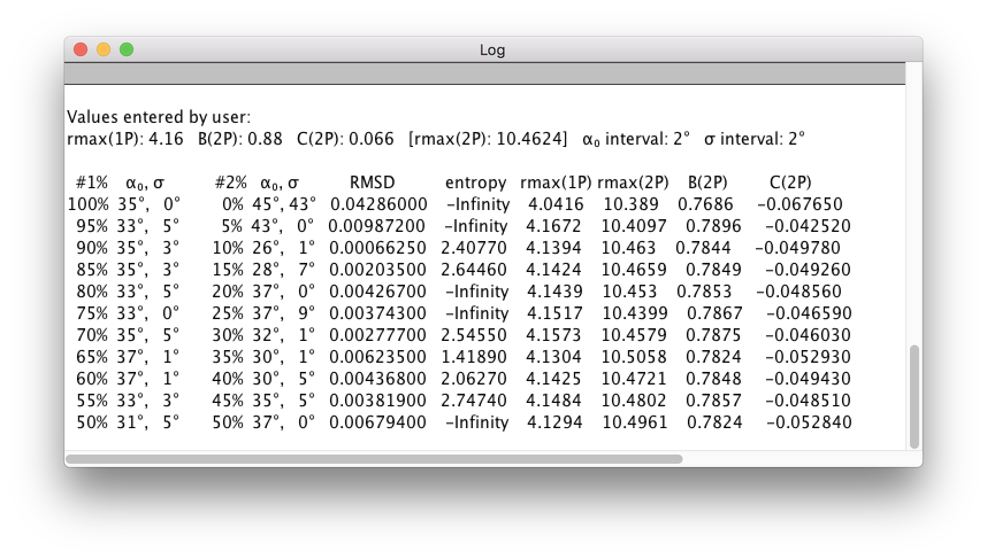  
Example output of the ‘t’ macro: a list of combinations of pairs of Gaussian distributions, along with the corresponding RMSD values, distribution entropies, predicted 1PPM and 2PPM *r*max values and predicted *B*2P and *C*2P parameters.

**Predict LD [p]**This macro calculates LD (as a function of membrane orientation) based on 0,  parameters entered by the user, and displays the results as a plot.

|  |  |
| --- | --- |
|  | The main dialog of macro ‘p’, asking the user to enter the values of parameters of a Gaussian distribution of molecular orientations, namely the mean tilt angle (α) and the tilt angle distribution width (). |

Upon pressing ‘OK’, the macro generates a plot of LD (log2(*r*)) as a function of membrane orientation (angle θ), both for 1PPM (blue trace) and 2PPM (red trace). The plot contains information on expected values of *r*max, log2(*r*max), *B*1P, *B*2P and *C*2P parameters.

|  |  |
| --- | --- |
|  | An example of a plot of expected LD (expressed as log2(*r*)), as a function of membrane orientation (angle θ). Appearance of the plot can be modified in the ‘More’ menu. |